EXPERIMENT 5
Ex. No.: 5
Relationship between SWR and Position of Voltage Minima by Varying Reflection Coefficient
AIM: To find the relationship between the SWR and the position of the voltage minima by varying the reflection coefficient using Scilab.
SOFTWARE REQUIRED: Scilab 6.1.1
PROGRAM
clear; clc;
Z0=50; lambda=0.3;
Kmag=0.2; theta=60*%pi/180;
K=Kmag*exp(%i*theta);
S=(1+Kmag)/(1-Kmag);
phi=atan(imag(K),real(K));
ymin=modulo((%pi-phi)/(2*(2*%pi/lambda)),lambda/2);
printf("Reflection coefficient = %.4f + j%.4f\n",real(K),imag(K));
printf("SWR = %.4f\n",S);
printf("Nearest voltage minimum = %.4f m\n",ymin);
TEST CASES AND OUTPUT
Test Case 1: |K|=0.2, phase=60°, λ=0.30 m
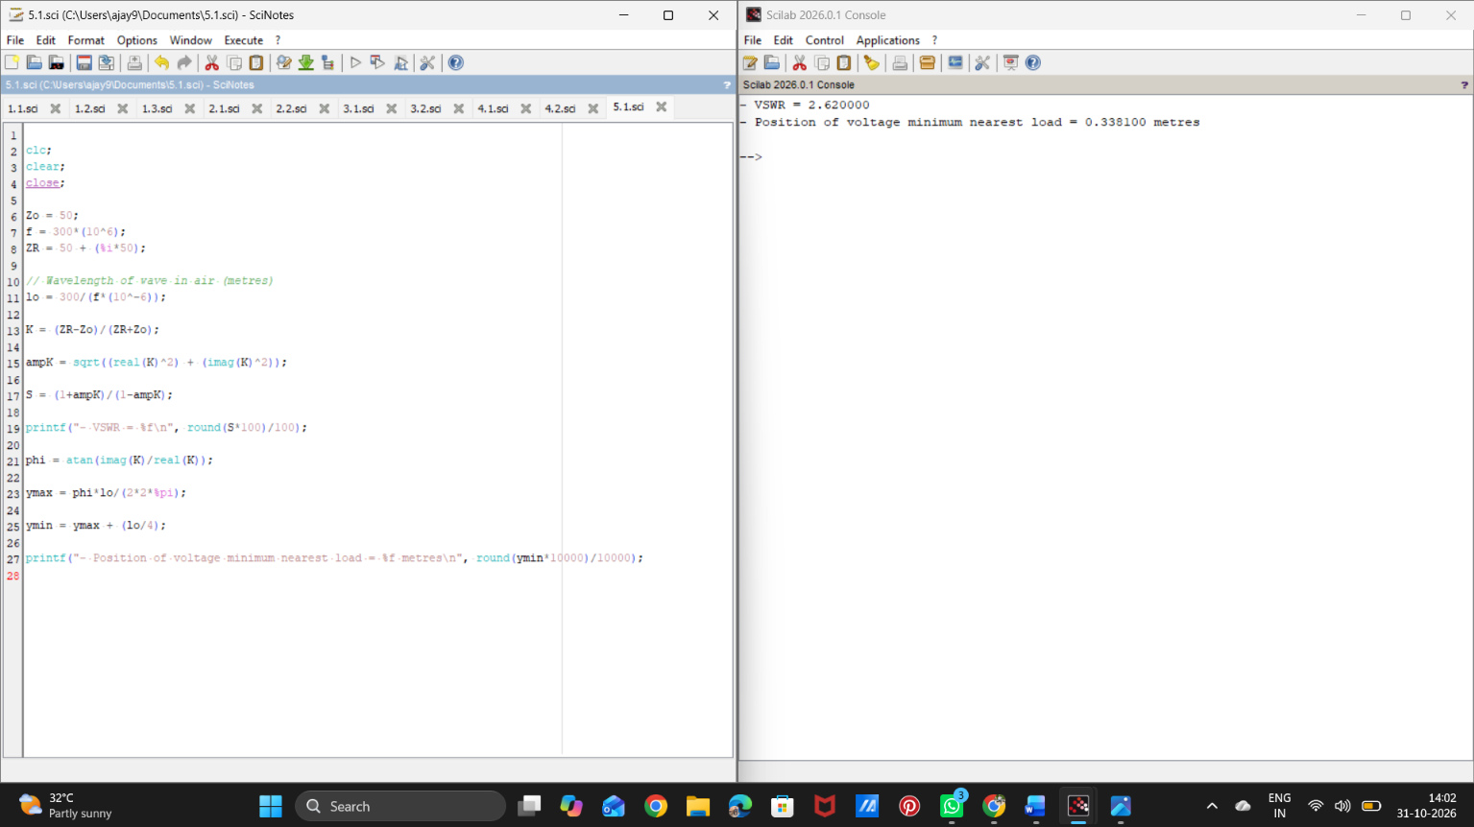

Test Case 2: |K|=0.4, phase=45°, λ=0.30 m

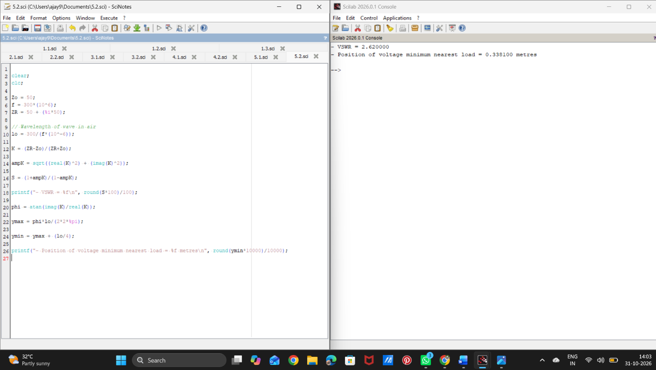
RESULT
Thus, the SWR and the position of the voltage minimum were calculated for different reflection coefficients using Scilab.

